**Project Team 27**

Sprint #2

Week #2

Team Member Name – Swapnil Makarand Joshi

What I did since the last week scrum?

1. Designed UML Diagram

What I plan to do next week?

1. Start development of GUI element

What blockers I have?

None

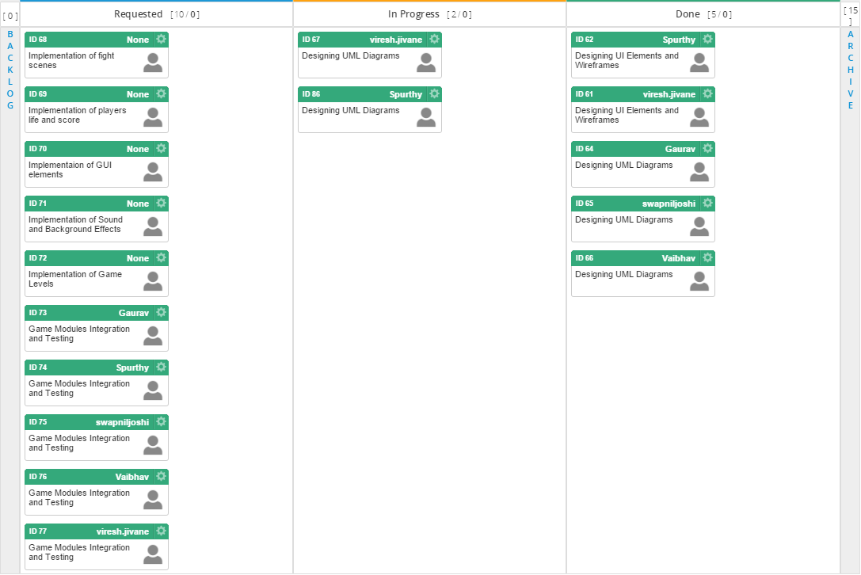

Task board in Kanbanize

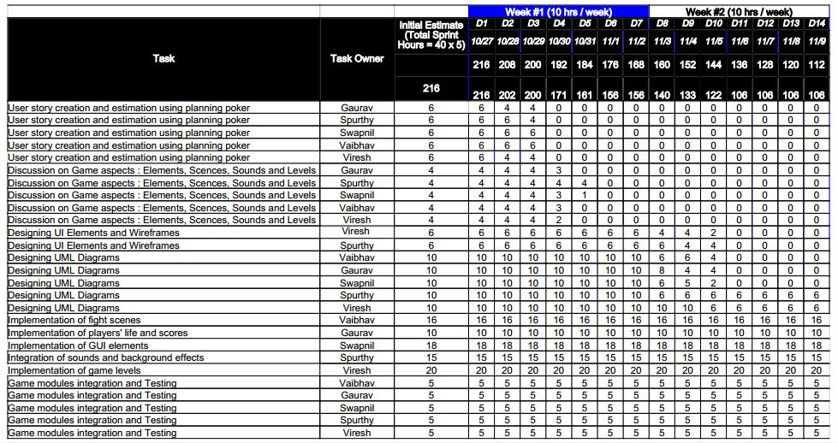

Weekly Standup Report

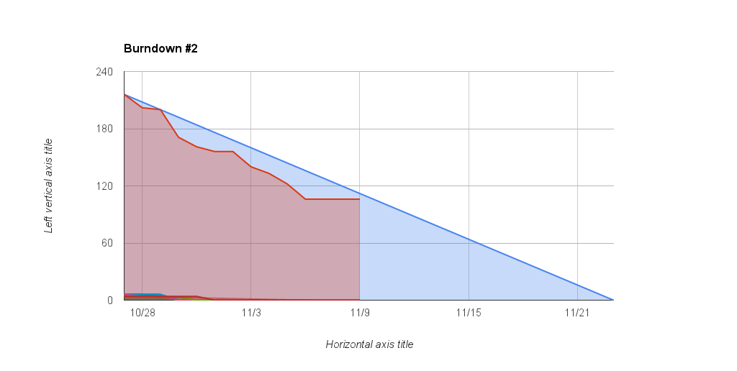

Burndown Chart